# CHAPTER 1 INTRODUCTION

## 1.1 Background of the Study

The development of systems to streamline data collection and improve organizational efficiency has evolved significantly over time. Prior to the advent of computer information systems, data management and communication within institutions relied heavily on manual record-keeping, which was time-consuming and prone to errors. Paper-based systems dominated until the integration of basic mechanical tools like typewriters and ledgers, which, although slightly more efficient, still presented limitations in terms of scalability, speed, and accuracy (Laudon & Laudon, 2020). As technological advancements progressed, organizations began to adopt electronic data processing, using simple databases that evolved into modern information systems. These systems enable real-time data collection, data sharing, and streamlined communication, addressing the inefficiencies present in earlier methods.

Information systems today, especially in critical sectors like law enforcement, have become essential for handling complex operations and improving accountability. In the context of the Philippine National Police (PNP), the need for an information system has become paramount to address the issues affecting the organization’s performance, especially in checkpoint operations. As checkpoints are vital in ensuring road safety and controlling crime, manual processes not only lead to inefficiencies but also hinder accurate reporting and data analysis. By establishing a robust information system specifically designed for PNP checkpoint operations, the organization can enhance the monitoring of officer performance, ensure transparency, and provide accurate real-time data to make informed decisions.

The proposed system will address several key issues, including the collection and evaluation of police performance data at checkpoints, allowing leaders to identify areas for improvement. This system will also serve as a tool to track accountability and increase operational transparency, as well as facilitate better resource allocation based on real-time data.

As the PNP works toward its mission of maintaining peace and order, this information system is a crucial step toward achieving greater efficiency and professionalism. The historical struggles of the PNP, from declining public perception to reports of inefficiency, underline the importance of adopting modern solutions to support its mandate as outlined in Republic Act (RA) 6975, RA 8551, and RA 9706. The development of this system will not only enhance police performance but will also support the larger goal of rebuilding public trust in the institution.

Historically, the General Santos City Police Office has played a critical role in maintaining peace and order. Since its establishment in the 1950s, it has evolved through various leaderships and challenges, including the renaming of its headquarters to honor Captain Fermin G. Lira Jr. Today, as society faces new challenges, the development of an information system to support police work in General Santos City will further strengthen its capacity to serve its citizens effectively (Patrol Plan 2030, n.d.).

**Statement of the Problem**

This study is intended to establish and implement an information system that will enhance the procedures and mandates of General Santos City Police Office (GSCPO) Checkpoint Operations.

Specifically, the study concentrated on the following questions:

1. What is the profile of the Police Officers in General Santos City Police Office (GSCPO) in terms of:
2. Name;
3. Age;
4. Sex;
5. Civil Status;
6. Present Position/Rank;
7. Highest Educational Attainment;
8. Number of years in service?
9. What are the profiles of Checkpoint Operations in terms of:
   1. Operations Profile;
      1. Date and Time;
      2. Location;
      3. Patrol In charge?
   2. Violation Profile;
      1. Violation Code;
      2. Description of Violation;
      3. Penalty?
   3. Violator’s Profile;
      1. Violator’s ID/License Number;
      2. Full Name;
      3. Age;
      4. Sex;
      5. Civil Status;
      6. Address?
10. How will GSCPO Checkpoint Operations Information System address the present data-filing system problem(s) of GSCPO checkpoint operations?
11. What is the level of efficiency, feasibility, and workability of the GSCPO Checkpoint Operations Information System?
12. What are the viewed enhancements and recommendations to improve the services of Police Officers in checkpoint operations upon implementing and establishing GSCPO Checkpoint Operations Information System?

## 1.2 Objectives of the Study

* To develop a system that provides real-time data and performance metrics to police officers and administrators, facilitating the efficient monitoring of checkpoint operations, officer activities, and incident reports;
* To provide accessible and easy way process on law enforcement procedure;
* To increase organization's efficiency in data gathering and monitoring information.

## Significance of the Study

With the current innovation in society, new generated systems are helpful in data gathering to have an easy and reliable data information. This study aims to establish an information system in data gathering and data dissemination. Thus, the database that will be established will be beneficial to the:

**General Santos Police Office**: The study will help General Santos Police Officers have a comprehensive and organized information.

**To The Filipino People:** This study will help civilians to have an easier access and have a reliable data information.

**To future researchers:** This study will be helpful as a reference for additional information in conducting a research study on a similar subject matter.

## Scope and Delimitations

This study aims to enhance the competency of General Santos police office to have an efficient and effective data information focusing on policies, procedures, place, and people.

# CHAPTER 2 REVIEW OF RELATED LITERATURE AND STUDIES

This chapter presents the literature and studies relevant to the research undertaking that were derived from theses/dissertations, books, journals, internet, and other reference materials. The chapter also shows the gaps to be bridged, synthesis of the study, the theoretical and conceptual frameworks. The last section of this chapter presents the operational definitions of key terms used in the study.

## Foreign Related Literature and Studies

According to Levinson (2004), “the patrol exercise is not only limited to crime control but also to reduce the fear within the neighborhood”. This builds a stronger relationship between police and community and wins the resident trust. Therefore, patrolling is one way of securing, protecting, preserving life and property, and assuring the safety of the people in the community.

Some selected foreign studies added a few instances of effective police activities. Effective police service involves the public and makes them aware of the operations done and carefully managed for their safety. Jack (2005) in his study entitled “A study of Factors Affecting Participation and Performance of Police Officers Undertaking the Queensland Police Service’s Management Development Program by Distance Education”. The management education for the police officers has played a significant role in the desired transformation of police service around the world form vocational to professional status. This study found factors that influenced the participation and performance of officers undertaking the program were their attitude to in-service professional development, how they perceived professional development, issues about their success potential, the level of personal, professional, and academic support they received, the impact of aspects related to program delivery and discourse with facilitators of the program.

Adebayo (2005) discussed attitudes and behavior of Police Officers in Nigeria. His focus was on the issue of lack of ethical behavior amongst the Police Officers. He established that to ensure adequate conformity to its constitutional roles, policemen and women are largely influenced by their training, skills, and submission to an ethical code. Adebayo (2005) however established that, a review of the Nigerian Police functions as provided in Section 4 of Police Act of 1967 and as amended by Police Act Number 23 of the 1990 constitution of the Federal Republic of Nigeria would suggest that pro-social behavior amongst the Nigeria police should include: involvement in rescue operations, helping accident victims, and responding to distress calls from victims of violent crimes whether or not they are assigned such duties. Other duties of the Police Officer under the Act are being friendly and courteous to strangers, tolerating inconveniences at work, being honest, kind, and reliable as peacekeepers and releasing suspects on bail without extortions. The Nigerian public experts discuss that whilst performing these tasks allocated to them, the police should only behave in ways that are advantageous to society but abstain from forms of behavior that are detrimental to themselves and the society at large. This requires complete decency, selflessness, protection of human rights, and the pursuit of citizens’ happiness on the part of the Police in the discharge of their functions.

“Determinants of the well-being of Police Officers in the Turkish National Police” evaluates the relationships of time balance, social relations, role conflict, perception of work environment, and fourteen control variables to police officers’ well-being in Turkish National Police. Individual police officers were analyzed to better understand the relationship between work environment on family life, social life, and the well-being of the police officers (Yildiz, 2008).

The findings of Yildiz’s study support some commonly expressed complaints of police officers. These findings also suggest that attention should be paid to the effects of time balance, income sufficiency, work environment, and workdays on the well-being of the officers. The analysis of this study revealed statistically significant relationships between following latent constructs: time balance and well-being, time balance and social relations, time balance and role conflict, social relations and role conflict, role conflict and well-being, and perception of work environment and well-being. In addition, six control variables (rank, department, optimism, isolation, income sufficiency, and working days per week) were statistically significantly related with well-being. No direct significant relationship was found between time balance and well-being, and social relations and well-being constructs. Eight control variables (gender, marital status, service time, extra work, confusion, region, work type, and working hours per day) had no significant relationship.

Eyram (2011) in her case study of Police Officers at the Cantonments Station, Ghana assesses the operations of the Ghana Police Service using Cantonments Police Station. Other findings include some of the hindrances to operations of Police officers are non – availability of vehicles which makes mobility very difficult, lack of logistics, poor infrastructure and lack of modern equipment’s, discrimination, lack of motivation and poor incentives, lack of manpower and limitation accommodation. Good supervision, cooperation from the public and logistics were identified as factors that helped to promote their duties efficiently. Most of the failures of the police officers were their inability to apprehend and arrest some notorious criminals. Another failure was their inability to show quick response to calls from the public.

Shane (2010) in his Journal of Criminal Justice entitled, “Organizational stressors and police performance”, this study examines the impact organizational stressors have on police performance. Evidence on police stress is mixed whether the nature of police work is inherently stressful. A growing body of research suggests police officers are no more stressed than other groups and police work is not especially stressful. Instead, organizational stressors may be a greater source of stress due to various structural arrangements, policies, and practices.

Vito and Higgins (2010) noted that senior police leaders should spend their time developing and sharing their vision for the organization, charting the journey by establishing strategic objectives and practicing collaboration and delegation of tasks. In their study of police managers enabling others to act was the most dominant leadership practice. Thus, police leaders should seek to empower their subordinates, sponsor their development, and prepare them for excellent performance. Police are required to understand and effectively operate in a complex social, political, and organizational environment (Casey and Mitchell, 2007).

Galino (2002), in his study entitled, “Role Performance of the Police and the Community as Correlates of Police Community Relations”, analyzed the roles performance of the Baguio City Police Office along the areas of peace and order maintenance and law enforcement. The author likewise analyzed the role performance of the Baguio City residents with regards to crime reporting and information system and their participation in criminal investigation and judicial process. Moreover, the researcher correlated the foregoing role performance of the police and the residents to the extent of police-community relations in Baguio City.

The findings of Galino’s study revealed that the respondents perceived the role performance of the personnel of Baguio City Police Office as generally “efficient”, and the role performance of the Baguio City residents as generally “favorable”. Both the police and community perceived police-community relations in Baguio City as “harmonious”. However, the study concluded that the Baguio City police have not reached its full potential in the delivery of police service to the people of Baguio City as far as peace and order maintenance and law enforcement are concerned. It likewise concluded that the residents of Baguio City seemed to have not fully realized the essence of social responsibility. Everyone who violates laws, rules, regulations, and ordinances is apprehended when they are reported. When this takes place, the identity of the offender is noted. This is considered as profile for it provides information about the individual.

## Local Related Literature

The duties of a police officer encompass a wide variety of tasks ranging from simple to complex performed in various situations and environments. Tasks asked of police officers include but are not limited to: confronting, and possibly arresting suspicious persons, using force (even deadly force) on community members, enforcing traffic laws (directing traffic, writing tickets, etc.), mediating disputes, assisting people in emergency situations, writing incident reports and providing a general level of security to the community. Police officers decide when and how to do many of these tasks on a day-to-day basis. Many of the most dangerous tasks they are asked to perform are done using broad discretionary power and carry grave consequences if errors in decision making are made by the officers. In the United States, police officers are granted great discretionary power for carrying out the duties and responsibilities of their job. While large of discretionary power can lead to abuses of its use, it is fundamental to the process and execution of justice by police officers by enabling flexibility and common sense to temper police decision making (Vila, 2010).

Specifically, two of the tasks that are performed by police officers generate concern in terms of officer and community safety: driving emergency vehicles; and decisions to use force, especially deadly force. These two tasks have the potential to lead to detrimental and catastrophic outcomes. Driving by police officers, which for many encompasses a large portion of their daily shift duration, is typically done at high speeds in highly distracting environments with expensive government owned vehicles. Decisions to use force, which are complex decisions under any circumstance, are frequently made under fast-paced ambiguous circumstances in which flexibility of thought, creativity of action, and adaption to uncertainty or unexpected events is vital to the success of the officer making the decision (Vila, 2006; Vila, 2010). These emotionally charged situations carry with them the risk that lives, property, and liberty could be lost at a given moment, and are often lost in a split second (Vila, 2006). Poor performance and impaired decision making during either of these critical job tasks can result in unintended deaths of police officers or community members, enormous monetary costs to cities, counties, departments, and communities, and broken relationships between the community and the police department.

St. Thomas Aquinas stated that, “Peace is the work of justice indirectly, in so far as justice removes the obstacles to peace, but it is work of charity, according to its very notion, cause peace” (Saint Quotes of Peace, n.d.). Articles, literature and reading materials about police, police organizations and law enforcement and the Philippine National Police itself, their works, functions, and responsibilities are numerous. They are useful in illustrating the police's main functions and strategies they undergo to enhance its system and procedures. Several aspects of the police force are dealt with and will shed relevance to the problem at hand.

Police Administration has been as the management of police organization, which is all about the work of the police officer or the utilization of talents to coordinate an effort and manage resources for the achievement of police organizational goals. Considering that a police organization as the primary responsibilities of the police administrators making it as the primary responsibilities in applying their individual initiative and skills necessary for the performance of the actual police roles and responsibilities (Breva Jr., n.d),

Quinanola (n.d.) describes a Filipino Policeman, as protector and friend of the people, his badge being a symbol of the citizen's faith and trust, his uniform a mirror of decorum and integrity, and his whole human person an oblation of enduring love for homeland, fellowmen, and God. The author further explains that a Filipino policeman emulates the valor of lapu-lapu, the serenity of Rizal, the leadership of Aguinaldo, the courage of Bonifacio, the idealism of Del Pilar, the wisdom of Mabini and the fortitude of Gomez, Burgos and Zamora; that a Filipino policeman has an oath to uphold for his Republic; to defend the Constitution, honor the flag, obey the laws and duly constituted authorities; that he has a covenant with his people to comply; to safeguard and protect them even beyond the call of duty, and that he has a legacy to fulfill for his family; to bequeath unto them the one and only treasure of his life - an unblemished name. These are the optimistic perspectives of a person who has high regard for a police officer that the people envisioned from way back. Not with standing, realities plague the PNP, staining the policeman's name.

Since the establishment of the PNP, police work has become a high profile, professional, round-clock public service. Its major mandate of peace and order is a basic requirement for the Philippine’s sustainable development. As stated in Section 4, Article 2 of the 1987 Constitution of the Republic of the Philippines provides that, the prime duty of the government is to serve and protect the people. The maintenance of peace and order, the protection of life, liberty, and property, and the promotion of general welfare are essential for the enjoyment by all the people of the blessing of demography.

The Philippine National Police was created under Republic Act (RA) 6975 on December 13, 1990. It was formally activated on January 29, 1991, coinciding with the casing of colours or official deactivation of the Philippine Constabulary (PC) and Integrated National Police (NP), its forerunner organizations. The country's national leaders sought to further improve police service and institute true reforms, modernization, and reorganization of the PNP with the passage of RA 8551, which provided for the rationalized distribution of manpower to maximize personnel deployment in the street and communities. To support this strategic formula, the law provided for complementing benefits to raise the quality of life of every policeman and policewoman.

The Philippine National Police Law Enforcement Manual establishes the nature of the functions of law enforcement in the defence of public order and the manner in which these functions are exercised to have a direct impact on the quality-of-life individuals as well as of society as a whole. Conscious of the important tasks which law enforcement officers are performing, but aware, nevertheless, of the potential for abuse which the exercise of such duties entails, it is essential that certain important standards and guidelines for the humane performance of law enforcement functions be recognized and closely adhered to by all members of law enforcement agencies, to wit; all enforcement agencies should be representative of and responsive accountable to the community; all enforcement agencies shall ensure the ethical standards are strictly adhered to in accordance with popularly accepted and humane system of law and regulations; every law enforcement officer is part of the criminal justice system, the aim of which is to prevent, control and solve crimes; and every law enforcement agency should observe self-discipline in conformity with the principles and standards provided and ensure that the actions of law enforcement officers are responsive to public scrutiny. The manual is widely adhered to by the organization.

Casey (2007) stated that police are required to understand and effectively operate in a complex social, political, and organizational environment. Pnp. Chief Police Director General Avelino Razon, Jr, brought forth the concept of servant leadership through the development of Mamang Pulis and Aleng Pulis as dependable, approachable, presentable, humane, and God-fearing police officers closer to people.

Successions of PNP top officials have seen various salient programs for police professional development. It can’t be denied that the PNP suffered for a long time from a tarnished image, a bad reputation brought about by perceived graft and corruption and abuse of authority by some members of its uniformed personnel coupled with the vulnerability of the organization. Police Deputy Director Ricardo F. De Leon (2005), for his part, pushed for the KASUROG COPS when he was Regional Director of the Police Regional Office 5. He widened KASUROG COPS when he became one of the highest officials of the PNP. His brainchild guided the police while doing their jobs as public servants. KASUROG COPS stands for the value of partnership, individual worth and dignity, integrity, and trust, commitment to service, and accountability. De Leon elucidated that KASUROG COPS is a philosophy, a mind-set, a way of life and an empowered action program where community folks and their police actually and physically work hard to eradicate crimes and their causes down to the Barangay level. It progressively assisted in alleviating poverty in the region where 55-57% of the population is below the poverty line. Kasurog entails shaping of the hearts and minds of the people. It is a total change from within an individual that takes his heart and instils it in the virtues of compassion, generosity, and charity in the attainment of public service among on the least, the last and the lost among the populace for there are so many.

From the vision of a capable, effective, and credible police force, the PNP has now adopted the enhanced vision: "Imploring the aid of the Almighty, by 2030, we shall be a highly capable, effective and credible police service working in partnership with a responsive community towards the attainment of a safer place to live, work and do business" (Philippine National Police Transformation Plan, 2015). With this enhanced vision, the PNP is once again guided by its philosophy of service, honor, and justice, through consistent demonstration of the PNP's core values of being Maka-Diyos or God-fearing, Makabayan or nationalistic, Makatao o humane, Makakalikasan or nature-loving.

In the Philippines, a country located in Asia, law enforcement has been mainly entrusted to the main law enforcement group, the Philippine National Police, in collaboration to other law enforcement agencies like the National Bureau of Investigation, Bureau of Corrections, Bureau of Jail Management and Penology, Bureau of Fire Protection; and the auxiliary groups like the Barangay Tanod, Traffic Management Groups, Security agencies and the like.

Police as law enforcers are mandated to ensure that the rule of law is implicated in the spirit equality for all citizens. However, some police are perceived as failing to live up to duty and uphold the law, but of directly violating the human rights of citizens or excessive use of force. Moreover, in the performance of their duties, police officers routinely make critical decisions which require discretion on their part. Uncontrolled discretion may result in serious problems that can cause damage to police organizations background.

Values of police officers always have connection to their performance. It is a principle or standard held in high esteem by an individual and is related to all aspects of one’s personal and work life (Oxford Dictionaries, n.d.). Values develop so that individuals can meet their needs in socially acceptable ways. The more individuals know about their own values, the better they will be at determining which work environment best fits their personal and professional needs and the skills they want to use and develop. Research suggests that the values are stable and predictable of behaviour over time. Thus, values play a central role in human motivation, achievement, and decision-making processes. Work values are thus one aspect of an individual’s value system.

Philippines has numerous government organizations which are established and intended to help and serve the Filipino citizens. Under the Philippine Constitutions, Article XI, Section 1 states that: Public Officer is a public trust. Public Officers and employees must always be accountable to the people, serve them with utmost responsibility, integrity, loyalty and efficiency, act with patriotism and justice, and lead a modest life (De Leon, 2002).

In the Philippines, a country located in Asia, law enforcement has been mainly entrusted to the main law enforcement group, the Philippine National Police, in collaboration with other law enforcement agencies like the National Bureau of Investigation, Bureau of Corrections, Bureau of Jail Management and Penology, Bureau of Fire Protection; and the auxiliary groups like the Barangay Tanod, Traffic Management Groups, Security agencies and the like.

Police as law enforcers are mandated to ensure that the rule of law is implicated in the spirit equality for all citizens. However, some police are perceived as failing to live up to duty and uphold the law, but of directly violating the human rights of citizens or excessive use of force. Moreover, in the performance of their duties, police officers routinely make critical decisions which require discretion on their part. Uncontrolled discretion may result in serious problems that can cause damage to police organizations background.

Performance evaluation is an effective tool in influencing behavior since employees tend to conform to prescribed standards in order to achieve higher performance ratings. Hence, dishonesty is a major problem in government; integrity ought to be one of the ratable factors in performance evaluation (Ursal 2006).

Performance evaluation in PNP shall be administered in accordance with the rules and regulations and standards, and a code of conduct promulgated by the Commission for members of the PNP. Performance evaluation system shall administer in such a way as to foster the improvement of individual efficiency and behavioral discipline as well as the promotion of organizational effectiveness and respect for the constitutional and human rights of the citizens, democratic principles and ideals and the supremacy of civilian authority over the military (Breva Jr. n.d.).

Performance measures include: policy – to assist in the formulation and implementation of planning and budgeting – to assist in the planned change; quality – to improve the standards of the service content and of the organizational effectiveness, economy – to review the distribution and effective uses of resource; equity – to ensure fair distribution and accessibility to users; and accountability – to increase control and influence over decision-making. Ultimately, there should be performance standards, but this should be for much later, when performance can already be measured with some degree of reliability and validity. Performance of officers cannot just measure with lazy and uncertain rod. When one is assigned, he/she must have performance goals, otherwise he may experience a sense of injustice, a feeling of intense dissatisfaction and of being treated unfairly. Then, there will always be resistance to change, the worst of which will come from individuals within the organization, the enemies within (Tantuico Jr., 2001).

According to Jocano (2000), “work refers to the commonly shared set of beliefs about work and how these beliefs impede or hasten the attainment of goals through work”. These beliefs influence how people work, how they value their work, and how they behave in the workplace.

Worker motivations, perceptions, and job performance in the public and private sectors have been of interest to researchers from various disciplines for many decades. In this research, factors related to the well-being of police employees in relation to their job performance are the focus. The literature suggests a strong relationship between police officers’ personnel well-being and job performance; as well, higher individual police officer performance is also associated with enhanced organizational performance (Berry, 2004). By analyzing the factors affecting well-being, proper intervention strategies for improving the well-being and the performance of officers and thus the police organization overall, can be developed.

## Related Studies

### Local Study

In the study of Mari et al. (2011), it was investigated that in a survey conducted among their respondents, the implementation of Police Patrol Unit is effective in addressing the peace and security in the community.

The study of Tais et al. (2012) on the status of Police Patrol Unit stated that Police Visibility Operation is very important for the prevention of crime and suppression of criminals.

### Foreign Study

Random preventive patrol strategies are based on the idea that visible police presence in an area provides a general deterrent effect on crime and that, subsequently, the general public’s fear of crime is reduced by those same police presence. It would be expected, as a result, that crimes that would normally take place in public areas, such as general property offenses or street crimes, would be more significantly impacted by preventive patrolling practices, whereas offenses typically committed in relative seclusion would be less susceptible to the deterrence effects of preventive patrolling. The utilization of police resources for random preventive patrol activities is, however, ineffective at deterring crime and apprehending offenders. Research suggests that targeted preventive activities in strategic zones where the majority of crimes occur, or when treatments driven by specific policies or practices aimed at meeting strategically defined goals are utilized, is far more effective in reducing crime (Sherman & Weisburd, 1995).

The first study that aimed to discern the effectiveness of preventive patrolling practices took place in Kansas City, Missouri in 1972-1973. The Kansas City Preventive Patrol Experiment took place within fifteen beats, and each beat was assigned to a proactive group where preventive patrols were increased, a control group where no changes were made to preventive patrolling practices, or a reactive group where preventive patrolling was suspended (Kelling et al., 1974). Generalized, the findings of the Kansas City Experiment showed no significant impact on crime deterrence, citizen fear of crime, community attitudes toward the police, or police response time (Kelling et al., 1974).

The Kansas City Experiment suffered from several errors in methodology, as outlined by Larson (1975), but also provided a number of interesting facts surrounding patrol deployment and perceived police presence as an unintended by-product. It is important to first note the most applicable shortcomings identified in the Kansas City Experiment in order to understand why the general finding that preventive patrol activities appeared to have no significant impact cannot be taken at face value. Perhaps most importantly, the areas designated as reactive beats still received a significant visible police presence through responses to service calls, the routine operations of specialized units, and patrol-initiated activities such as building or car checks and stopping motorists for traffic violations. Further, as a result of using multiple patrol units dispatched in response to calls for service in the reactive groups and coupled with an increased use of emergency lights and sirens, there was no diminished public awareness of a police presence in these areas.

In essence, according to Larson (1975), the nature and design of the Kansas City Experiment served to empirically test whether patrol units could be spatially redistributed within a confined region or zone without an actual or perceived degradation in service, instead of actually testing whether preventive patrol practice were effective. Understanding the shortcomings of the Kansas City Experiment results in a clearer understanding of why the conclusion that routine preventive patrol activity has little, or no value is not justifiable. In fact, Larson’s (1975) analysis of the experiment provides the framework for understanding Sherman and Weisburd’s (1995) hypothesis that patrol dosage in the Kansas City Experiment varied by a statistically insignificant amount from normal patrol levels, which is why the Kansas City Experiment seemingly provided support for the concept that preventive patrol has no effect even though other studies provided contradictory evidence and conclusions. It is through targeted patrol dosage in specific zones, or hot spots, and through the use of strategically defined objectives during patrol activities, that the effectiveness of certain types of preventive patrol efforts becomes identifiable.

However, in United Kingdom there is a program that have been evaluated specific safety outcomes and found improvements due to the presence of police in some areas. These programs hold lessons for community safety in the United Kingdom. Police Visibility is a comprehensive community and citizen safety program that incorporates many interventions and partners to improve safety and to create safer working environments and safer communities. There is evidence that visibility of police has reduced offending behavior and victimization, reduced crime rates, and has provided safer environments. Citizens in the community report that they felt safer since the program was introduced. Other benefits of the visibility of police were established to improve relations between people and the police and increase the level of respect people have for their fellow citizens.

Sherman and Weisburd (1995), McGarrell et al. (2001), and Braga (2001) all provide insights into the effects of “hot spot” policing, which is a form of place-oriented preventive patrol. McGarrell et al. (2001) also examined the effects of providing a clear strategic goal for officers during preventive patrol activities, namely the locating and seizure of illegally possessed firearms, and its subsequent effect on crime. These studies provide the basis for the conclusion that certain preventive patrol practices are effective under certain circumstances and random preventive patrol activities are ineffective, even though the conclusions of the aforementioned Kansas City Experiment dominated police thinking about patrol strategies for more than two decades (Sherman & Weisburd, 1995).

Tested the effects of intensified, but intermittent, patrol on identified “hot spots” of criminal activity in Minneapolis, Minnesota. In the study, one hundred and ten locales were identified and split into two even groups, with the experimental group receiving substantially increased levels of patrol dosage as opposed to the control group. It is worth noting that the experiment was designed only to measure the effect of heightened police presence at these locations, and that the activities of officers during the time they were within each zone was not restricted; in fact, the observed activities of officers during the time spent within the boundaries of the hot spot included activities unrelated to patrol, such as reading, sunning, and general conversation. The study found clear, albeit modest, general deterrence effects as a result of increased police presence in the targeted areas, though with two caveats: first, there was no test of whether criminal activity was merely displaced to other areas so general deterrence effects throughout the community cannot be claimed, and second, the experiment had not been replicated and therefore may be limited in external validity thus far.

Along a similar line of inquiry, evaluated the effect of directed patrol efforts, wherein police units were freed from the responsibility of responding to calls for service and were instructed to proactively patrol their assigned neighborhood with an emphasis on locating and seizing illegally owned firearms. Two different methodologies were utilized in order to examine the effects of a general deterrence approach versus a specific deterrence approach: in target area one, police were instructed to increase traffic stops to maximum levels in order to create a sense of significantly increased police presence, testing a general deterrence strategy that was also anticipated to lead to seizures of illegal weapons and drugs; in target area two, police were instructed to focus on investigating suspicious persons, a specific deterrence strategy, and conducting more thorough investigations for illegal weapons and drugs with each suspicious person. Interestingly, the results of the study show a significant reduction in firearms related crimes in the specific deterrence beat, but actually show an increase in the general deterrence beat. One possible explanation provided by McGarrell et al. (2001), for the success of the targeted offender/specific deterrence approach lies in the possible interpretation of police actions within that zone, as a result of proactive, directed preventive patrol efforts, as heightened surveillance as well as removing firearms from those potential offenders most likely to use them. In effect, a directed strategy for preventive patrol activities in higher crime locations yields a significant impact in the reduction of violent crimes.

According to Bragas (2001), he stated that perhaps the most compelling evidence for the effectiveness of place-oriented preventive patrol as opposed to random preventive patrol analysis and systematic review of “hot spot” policing studies. Out of nine studies, seven showed noteworthy crime reductions as a result of place-oriented patrol activities, and it should be noted that intervention types ranged among three broad categories: enforcement problem-oriented-policing (POP) interventions, directed and aggressive patrol programs, and the use of crackdowns and raids. It is also important to note that methodological problems in the research and evaluation designs of two studies most likely accounts for the lack of observed reduced criminal activity in said studies, and the remaining study showing no discernable impact on reducing crime suffered from issues in implementation that could account for a lack of significance in results. Overall, review contributes to a growing body of research evidence supporting the conclusion that targeting “hot spots” of crime with focused, strategic intervention efforts is effective at reducing crime, both at the targeted zone and in surrounding areas, and is far more effective than random preventive patrol activities. These findings also provide positive indications that displacement of crime from a targeted zone to a less actively patrolled zone may be unfounded, though only five of the studies review measured the potential displacement of criminal activity.

Given the briefly summarized results of the aforementioned experiments and systematic reviews, it is difficult to justify random preventive patrol efforts in light of far more effective results from directed patrol activities in the reduction of crime. Theoretically, random preventive patrol activities should provide general deterrence effects for publicly visible crimes, such as vandalism, disorderly conduct, robberies and burglaries, and potentially aggravated assault. However, targeted patrol activities appear to have the same effect with regards to increased public visibility in providing a level of general deterrence while simultaneously providing far more effective specific deterrence effects, as noted in the studies and reviews above. Therefore, the effectiveness of random preventive patrol activities is conclusively inefficient when compared with other methods of targeting and reducing criminal activity within any given zone (Braga, 2001).

# CHAPTER 3 TECHNICAL BACKGROUND

## Technicality of the Project

The proponents have developed a web-based program that the users can access through any digital platform. The GSCPO Checkpoint Operations Information System is an online system for Police Officers in keeping records and maintaining public safety, security, and deterring criminality in the streets. These are the technical terms that are being used in this project: Text Editor - Visual Studio Code, Server-client side - PHP, HTML, CSS, JavaScript, Apache, Database - XAMPP, MySQL, Functionality - Web Application, PhpMyAdmin. Some of the terminology indicated above is also the technology used for our project.

## Details of the Technologies to be used

This project will be available in any technology, to run the system it uses such as mobile phones, laptops, and computers.

In developing this project, the following are the technology tools will be used:

**VISUAL STUDIO CODE - is** a free open-source text editor by Microsoft and it is available for Windows, Linux, and MacOS. Although the editor is lightweight, it contains some powerful features that have helped VS Code become one of the most popular development environment tools in recent years.In the development of the system, we used Visual Studio Code for encoding the system’s source code, in order to achieve accurate and rapid data and information collecting.

**PHP -** is a widely used open-source general-purpose scripting language that is particularly well suited for web development and can be embedded into HTML. PHP is a programming language used by web designers to create dynamic content that interacts with databases. PHP generally runs on a web server, and it can also be used for command-line scripting and server-side scripting.

**HTML -** is a standard markup language for creating web pages. HTML is the code that is used to structure a web page and its content. It tells a web browser how to display text, images, and other forms of multimedia on a webpage.

**CSS -** stands for Cascading Style Sheets, this language is used to style and to format the layout of Web pages written in a markup language such as HTML. CSS is in charge of a web page's style and appearance. CSS allows developers to manage the color of the text, font style, paragraph spacing, how columns are scaled and laid out, what background images or colors are used, layout designs, display variants for different devices and screen sizes, and a multitude of other effects. CSS enables Web developers to establish a uniform appearance across multiple pages of a website.

**JAVASCRIPT - is** a scripting or programming language that allows developers to implement complex features on web pages. JavaScript is a lightweight programming language used by web developers to generate more dynamic interactions when creating web pages, applications, servers, and even games. It is also generally used by developers alongside HTML and CSS. The scripting language works well with CSS in formatting HTML elements. However, JavaScript maintains user interaction, which CSS cannot achieve on its own.

**XAMPP V3.3.0 -** is a popular cross-platform web server that allows developers to develop and test their programs on a local webserver. The developers will use this as a development tool, to enable web designers and programmers to test their work on their own computers without needing to connect to the Internet.

**MYSQL -** is the world’s most popular open-source relational database management system. MYSQL will be used by the developer because it is fast, reliable, scalable, easy to use, and it is one of the system development compatible databases.

**APACHE -** Apache HTTP Server is a cross-platform open-source web server. It is fast and secure enough for running large websites.

**BOOTSTRAP -** for creating the graphical user interface of a web-based application.

**CHAPTER 4**

**METHODOLOGY**

This chapter outlines and assesses certain essential processes and activities put into place by the researchers who are backing the study as a means to successfully accomplish the study's aims. The latter shows an overview of the responses as well.

**4.1 Research Design**

This study used Primary Data, which is data collected directly from the source by doing interviews or surveys, to support the study. The proponents were able to utilize these to develop assessments that will help further enhance the proposed system in the future.

**4.2 Research Procedure**

The researchers used the following methods in gathering data:

* **Survey method -** The proponents prepared their own questionnaire that was given to the personnel of the company who were knowledgeable enough for the study. The constructed questions were based on the concept of the study and identified the significance of having this system.
* **Interview guide -** The researchers also performed formal and informal interviews to address some pertinent concerns about the information system's flow.
* **Data Gathering Procedure -** The subsequent procedures were done by the researchers in order to gather the requisite data. They’ve brainstormed ideas on how to start the study and disseminated tasks to each member. The researchers invested a lot of time, effort, and cooperation in producing their questionnaire.

The survey was constructed using pertinent questions that were altered from related research and particular questions that were developed by the researchers.

The gathered data and information were then analyzed as the basis for the Checkpoint Operations Information System.

**4.2 Proposed Design**

*(Figure I. Login Page)*

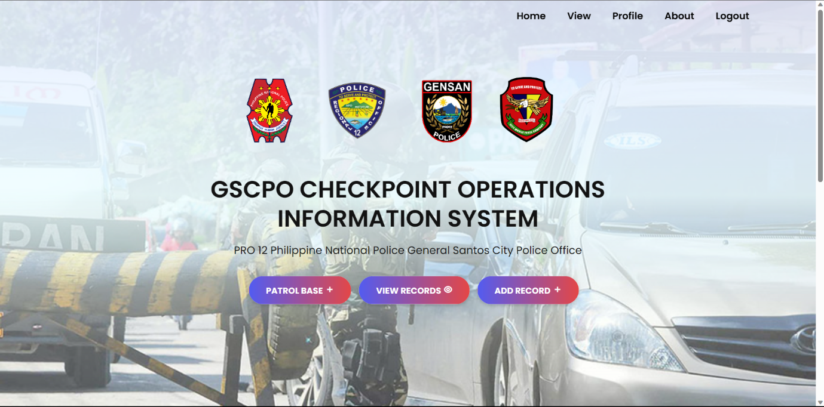

*(Figure II. Admin Page)*

*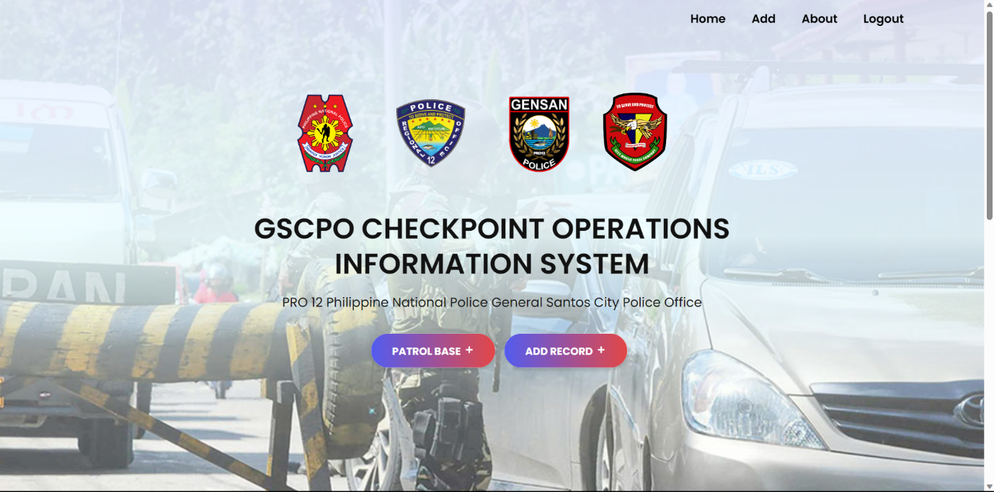(Figure III. Staff/User Page)*

*(Figure IV. Login Profile [add and view])*

*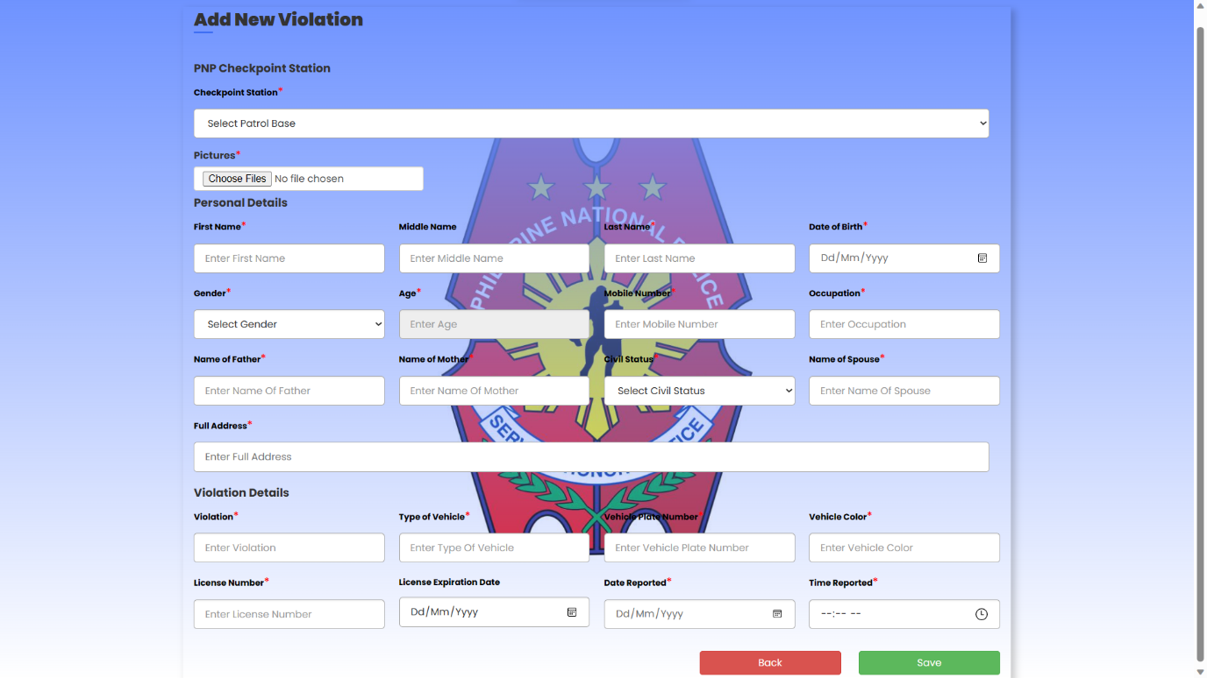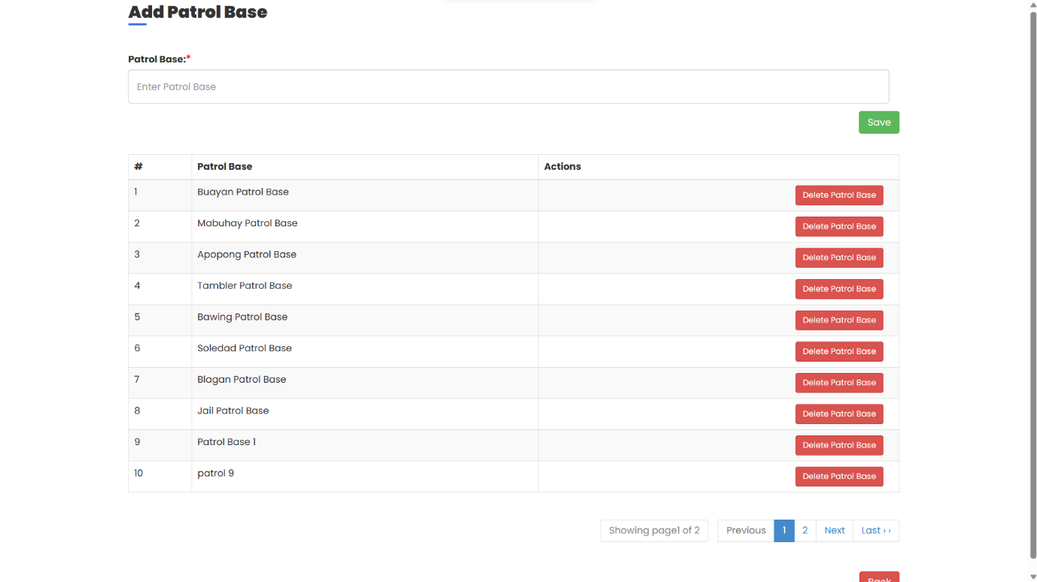(Figure V. Patrol Base Page)*

*(Figure VI. Admin Add Violation Page)*

*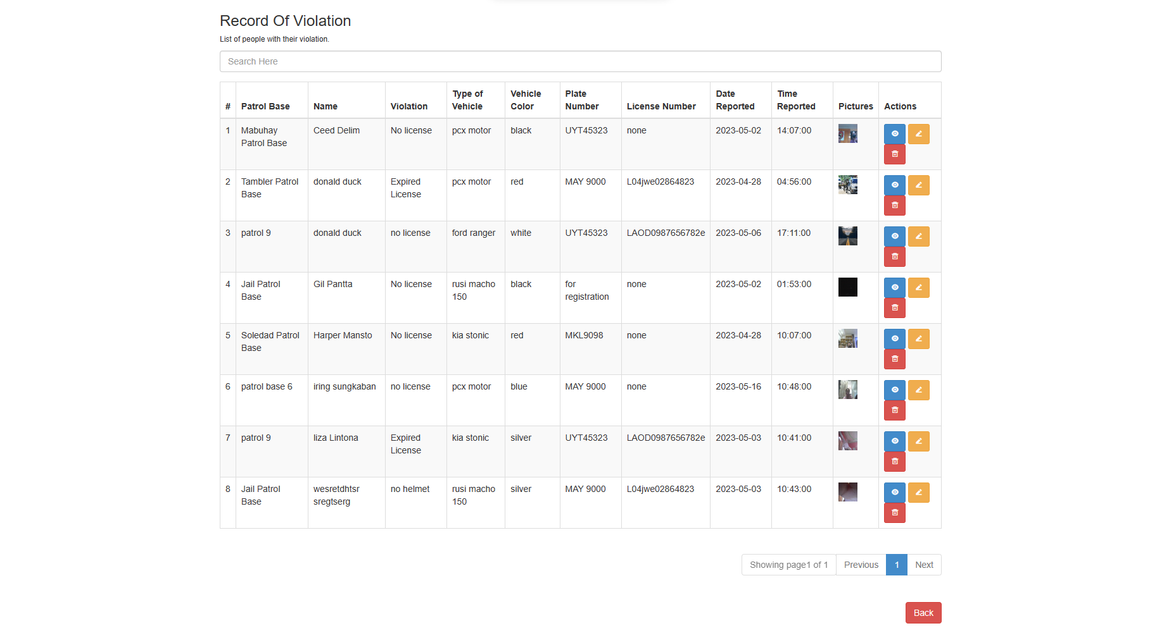(Figure VII. Admin Cam Page)*

*(Figure VIII. View Record Page)*

*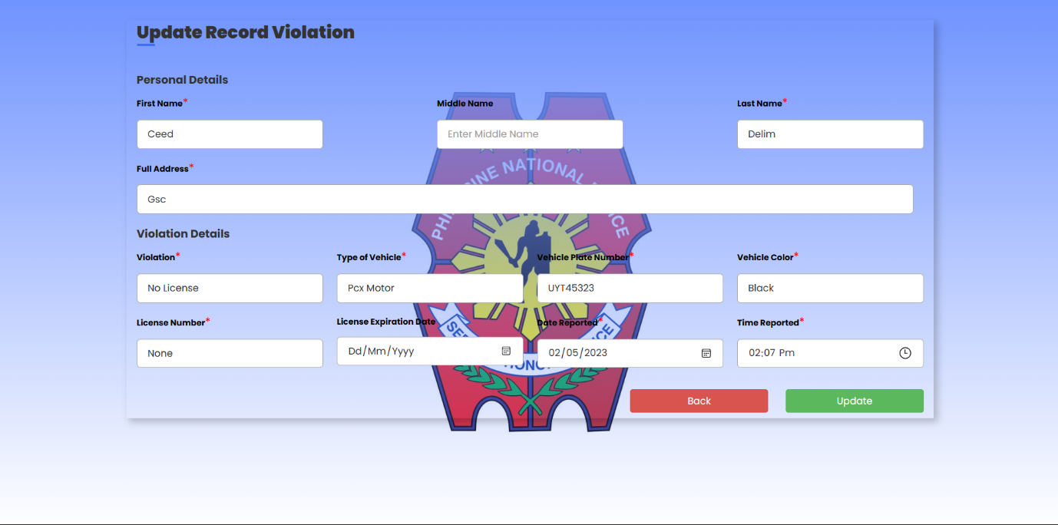(Figure IX. View Action Page)*

*(Figure X. Update or Edit Record Page)*

*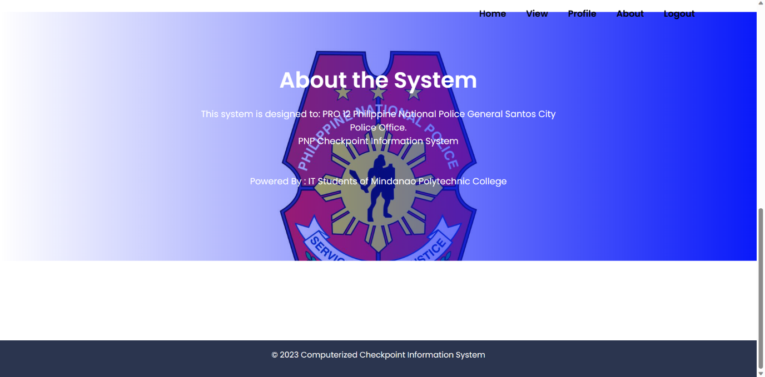(Figure XI. About Page)*

**4.5 Tables Relationship**

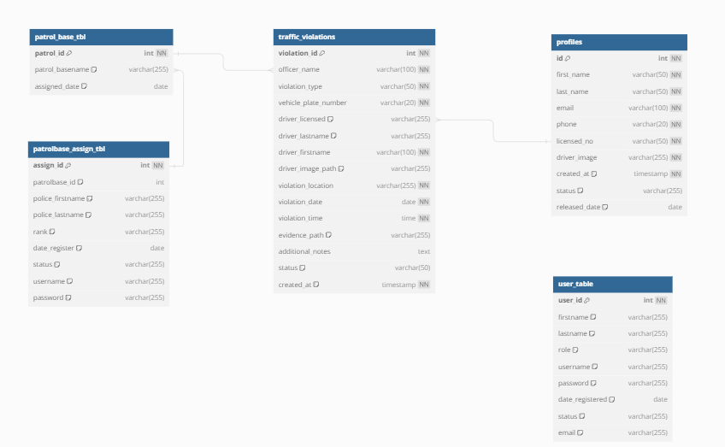

**4.5.1 Data Dictionary**

**User Profiling Table**



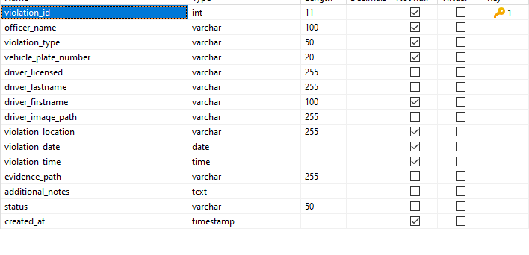 **Traffic Violation Table**

**Patrol Base Table**

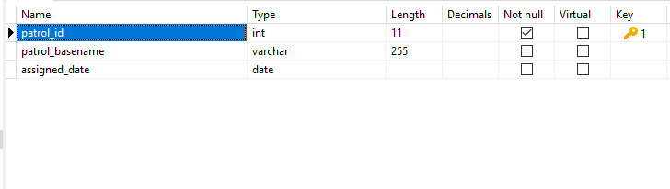

**Assign Police**

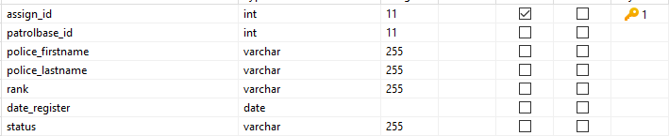

**Admin/Staff Table**



**4.6 System Flow Chart**

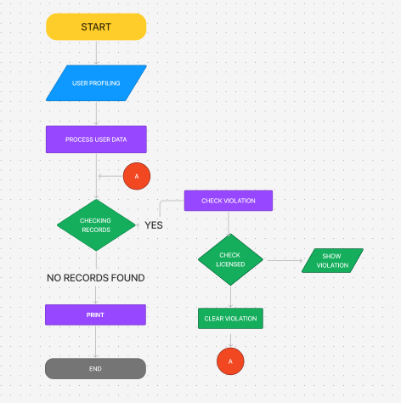

*(Figure XI: Workflow for Updating or Editing Records in the System.)*

**4.6.1 Data Flow Diagram**

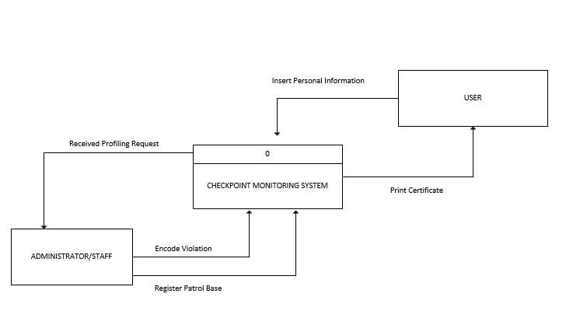*(Figure XII: System Workflow of the Checkpoint Monitoring System. )*

The diagram illustrates the workflow of the Checkpoint Monitoring System, detailing the interaction between the user, administrator/staff, and the system itself. The process begins with the administrator/staff receiving profiling requests, encoding violations, or registering patrol bases. Users are involved by inserting personal information into the system and can request to print certificates. The core system processes these inputs and commands, facilitating smooth monitoring and management of checkpoint activities.

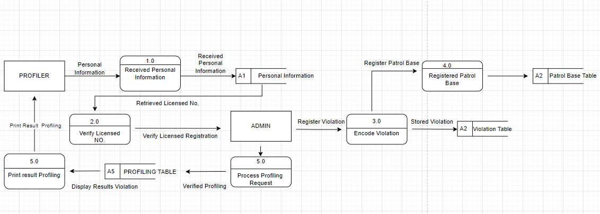

*(Figure XIII: Level 1 Data Flow Diagram of the Checkpoint Monitoring System. )*

This diagram represents the Level 1 Data Flow Diagram (DFD) for the Checkpoint Monitoring System, outlining the interactions and data flows between the user, administrator/staff, and the system. The process initiates when the administrator/staff receives profiling requests from users. They then encode violations and register patrol bases into the system. Users input their personal information directly into the system, which allows them to request the printing of certificates. The central system processes these data inputs and commands, ensuring efficient monitoring and management of checkpoint operations.

**CHAPTER 5**

**SUMMARY, CONCLUSIONS, AND RECOMMENDATIONS**

## 5.1 Summary

The overall goal of this research is to create a GSCPO Checkpoint Operation Information System for General Santos City. To efficiently create this system, the researchers used PHP and HTML for the front-end and MySQL for the back-end.

Before the system was effectively gathered, the proponents did numerous studies and data gathering. The proponents defined the problem and the background of the study in the first step. The scope and limitations were then established, along with the objectives. In the second phase, the study's supporters conducted internet research to acquire data and information. The system was then built by the proponents in the third phase using different techniques such as charts and diagrams. Finally, the GSCPO Checkpoint Operation Information System for the General Santos City Police Office was implemented. The system was also evaluated by the proponents to ensure that it is functional and error-free.

## 5.2 Conclusions

The proponents concluded the following based on the outcome of the study:

• Real**-time data and performance metrics:** The system successfully provided real-time data and performance metrics, improving the monitoring of checkpoint operations and officer activities.

• Accessible **law enforcement processes:** The system streamlined law enforcement procedures, making it easier for officers and administrators to manage incident reports and operational data, demonstrated by reduced processing times.

• Increased **efficiency in data gathering:** The system improved the efficiency of data collection and monitoring, as shown by fewer data entry errors and faster response times in addressing incidents.

• Improved **decision-making and accountability:** The system enhanced decision-making and accountability by providing accurate and timely reports that allowed for better resource management.

## 5.3 Recommendations

The proponents suggest the following improvement to the developed system:

* That the system will use ID scanner to automatically fill the data.
* That a feature be added where it can access camera and take multiple pictures, save to database in one row and display the pictures in one row.

BIBLIOGRAPHY

Websites

https://www.studocu.com/ph/document/visayas-state-university/computer-science/chapter-3 sample-content/29218205

References:

Laudon, K. C., & Laudon, J. P. (2020). Management Information Systems: Managing the Digital Firm (16th ed.). Pearson.

Patrol Plan 2030. (n.d.). Philippine National Police: The Journey to Transformation. Retrieved from [source].

VS Code references:

https://code.visualstudio.com/docs/editor/whyvscode

https://www.educative.io/answers/what-is-visual-studio-code

php references:

https://www.w3schools.com/php/default.asp

https://www.php.net/manual/en/intro-whatis.php

https://www.tutorialspoint.com/php/index.htm

https://codeinstitute.net/global/blog/what-is-php-programming/

html references:

https://www.theserverside.com/definition/HTML-Hypertext-Markup-Language

https://developer.mozilla.org/en-US/docs/Learn/Getting_started_with_the_web/HTML_basics

https://www.w3schools.com/html/html_intro.asp

css references:

https://www.tutorialspoint.com/css/what_is_css.htm

https://www.hostinger.ph/tutorials/what-is-css

javascript references:

https://www.hostinger.ph/tutorials/what-is-javascript

https://developer.mozilla.org/en-US/docs/Learn/JavaScript/First_steps/What_is_JavaScript

xampp references:

https://www.javatpoint.com/xampp

https://www.studocu.com/ph/document/visayas-state-university/computer-science/chapter-3-sample-content/29218205

mysql refeerences:

https://www.oracle.com/mysql/what-is-mysql/

https://www.studocu.com/ph/document/visayas-state-university/computer-science/chapter-3-sample-content/29218205

apache references:

https://www.techtarget.com/whatis/definition/Apache

APPENDICES